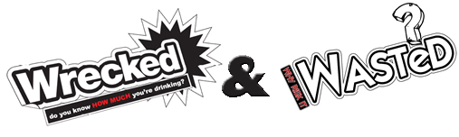
Wrecked and Wasted Battle of the Bands
Five local bands battled it out to become crowned the first ever Wrecked & Wasted Battle of the Bands Champions 2011. The event was organised as part of the local Wrecked & Wasted Campaign to raise awareness about the risks of drinking alcohol and substance misuse amongst young people.
The finalists were selected by local young people, who listened to music tracks uploaded to the Wrecked & Wasted website by local up and coming bands. Over a 1,000 votes were cast to select the finalists to perform at the finalists Battle of the Bands event held at Cheers Night Club, Dumbarton on Friday 2nd Sep 2011.
Over 200 young people aged 16 years and older, attended the event to enjoy music by the finalists including Playdead, Mellifluous, E for Exile, Hot Rails and Picnic Basket Nosedive. With plenty of fist pumping, dancing and head banging going on, the crowd enjoyed performances from each band and were keen to show their support to the best of West Dunbartonshire’s fast growing music scene.
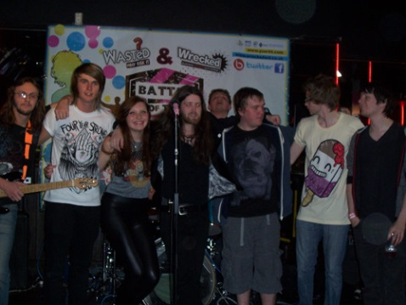
The each band put on an explosive performance making the judges decision as difficult as possible. Member of the judging panel which included Peter Clyde, “The quality of the performances were very good making it a very tough decision to decide on a winner, but overall Hot Rails put in an awesome set, which the crowd responded to and were well deserved winners”. Overall winners Hot Rails received a cheque for £500 worth of studio recording time with close runners up PlayDead, receiving £150 worth of studio recording time.
Laura Ward, Senior Youth Information Support Worker with Y Sort-It, said: “The Battle of the Bands has been a huge success, with bringing together young people from across West Dunbartonshire, to enjoy music and interact with each other in a safe environment. The event has been fantastic opportunity to promote the messages of the Wrecked & Wasted campaign and demonstrate to young people that there is no need to get wrecked or wasted, with alcohol or drugs to have a good night.”
Throughout the evening, Y sort it Youth workers trained in delivering alcohol brief interventions were also on hand to offer information and advice about alcohol and substance misuse.
For more information about the Wrecked & Wasted Campaign or future events please visit www.wreckedwd.co.uk or contact Y sort it on 0141 941 3308.

